**Homework 5 – Program Report**

**Arnav Guneta**

**Functional Requirements**

As a player of the connect 4 game, I get to pick the number of players so multiple people can play (up to 10). I get to pick the number of rows, columns, and number of markers in a row needed to win the game to customize the game for myself. As a player, I get to see the board, with the specified condition from before, to decide where to place my token. As a player, I will take turns dropping tokens into the grid in order to win. I need to get specified tokens in a row either horizontally, vertically, or diagonally to win. As a player, I get to view the board after placing my token so I can see what the board looks like. The game alternates players so there is competition. As a player, I can’t add tokens to a full column because it wouldn’t fit. As a player, I keep dropping tokens until either me or the opponents win or draw. After that, I get to choose if I want to keep playing so I can quit if I wanted to. As a player of the game, if I choose to play again, I can re-specify my board dimensions and markers needed in a row in order to win so I can keep playing with a board that I want.

**Nonfunctional Requirements**

The program must be coded in Java. The program must run on Unix (console- based). The program must be robust and be compatible for updates/ add-ons.

**UML Class Diagrams**

**GameBoard UML class diagram**

**checkIfFree(int c)**

**checkForWin(int c)**

**placeToken(char p, int c) GAMEBOARD**

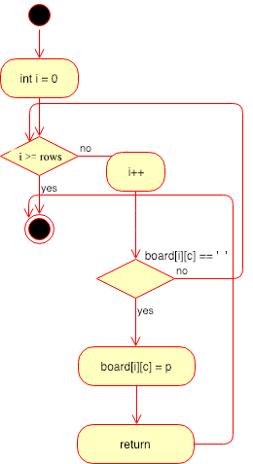

**checkHorizWin(int r, int c, char p)**

**checkVertWin(int r, int c, char p)**

**checkDiagWin(int r, int c, char p)**

**whatsAtPos(int r, int c) GAMEBOARD**

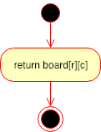

**toString ()**

**checkIfTie()**

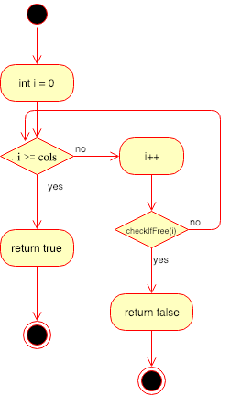

**getNumRows()**

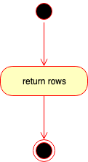

**getNumColumns()**

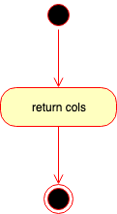

**getNumToWin()**

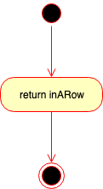

**placeToken(char p, int c) GAMEBOARDMEM**

**processButtonClick(int col)**

**ConnectXController UML class diagram**

